Test 3
20
TOTAL

Name .


1. Listen and number (1-6).


a.
b.
c.
d.
e.
f.

6
score

2. Look, read and circle.
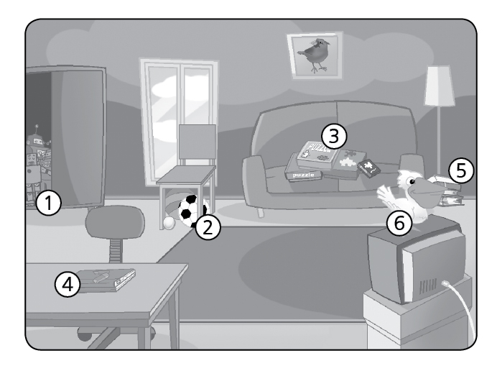

1. The robots are in / on the wardrobe.
2. The balls are on / under the chair.
3. The puzzles are on / under the sofa.
4. The computer is on / under the table.
5. The books are on / under the lamp.
6. The bird is on / under the TV.

6
score

4
score

3. Look, read and write. Yes, it is. No, it isn’t.
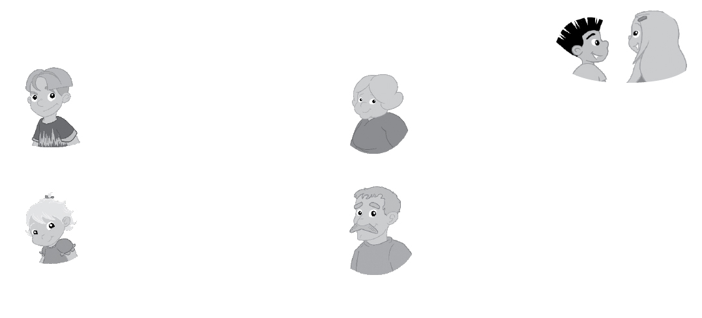
8
score

1. Is that your brother?

3. Is that your friend?

1. Is that your brother?

3. Is that your friend?

2. Is that your mother?

4. Is that your grandfather?

