Revision Test 5-8
40
TOTAL

Name .

1. Look and write. meat rice salad fruit pasta cheese

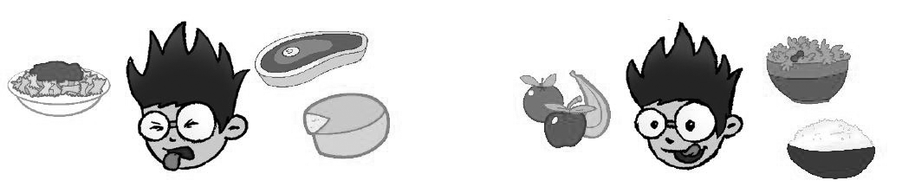
4
score

1. I don’t like pasta .

.

.

2. I like rice .

.

.

4
score

2. Listen and tick () or cross ().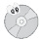
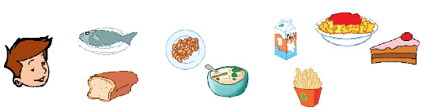
3.
1.
2.
4.
5.
6.
7.
8.

8
score

3. Read and match.
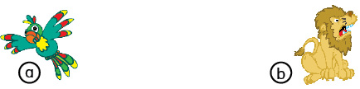
1. It can’t fly.
2. It can talk.
3. It can’t swim.
4. It can run.

4
score

4. Read and write. There is There are Is there Are there

1. a hospital.
2. three schools.
3. two parks?
4. a zoo?
4
score

5. Listen and number (1-4).

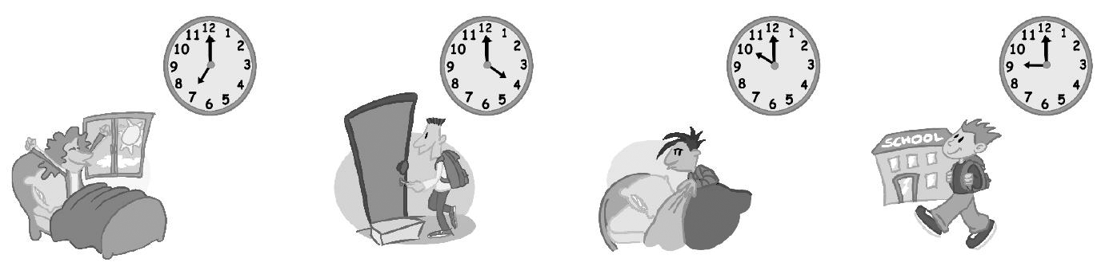

a b c d

4
score

6. Look and write. I’m You’re He’s She’s

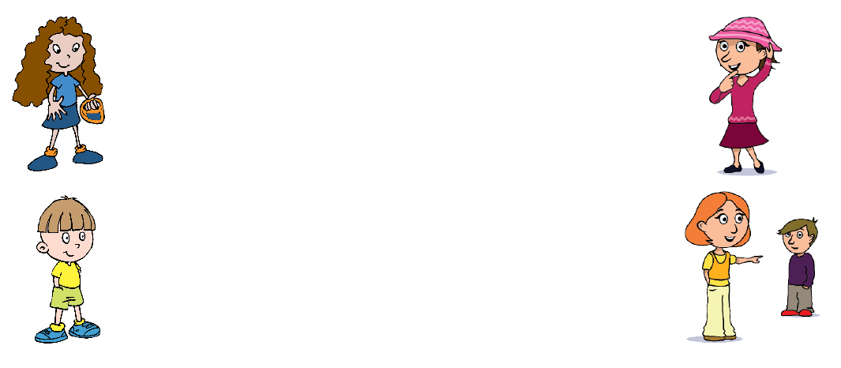

1. wearing a skirt.

33. wearing shorts.
2. wearing a hat.

4. wearing trousers.
4
score

4
score

7. Listen and tick () a or b.
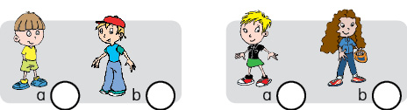
1. 2.
4
score

8. Answer about you.

1. Can you jump?
2. Can you swim? .
3. Are you wearing jeans?
4. Are you wearing glasses?
8
score

