Test 2
20
TOTAL

Name .


1. Listen and number (1-4).
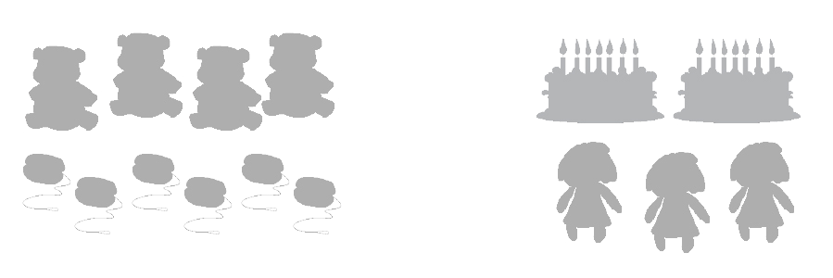
a.

b.
c.
d.

4
score

2. Listen and colour.
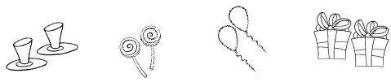
4
score

a.
b.
c.
d.

3. Look, read and circle.
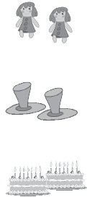

1. Are they dolls?
Yes, they are. / No, they aren’t.

2. Are they yo-yos?
Yes, they are. / No, they aren’t.

3. Are they cakes?
Yes, they are. / No, they aren’t.


4.
Are they dolls?
Yes, they are. / No, they aren’t.

5. Are they balloons?
Yes, they are. / No, they aren’t.

6. Are they presents?
Yes, they are. / No, they aren’t.
12
score

